6. Marine
6.1 Fish transects
Corralivorous fishes of the Chaetodontidae family (butterflyfishes) are excellent indicators of reef health (Crosby & Reese 1996). The butterflyfishes rely on the abundance and diversity of coral species on which they feed and shelter. In addition, fishes of the Serranidae family (groupers) are also good indicators as they rely on corals for cover and display a high level of territoriality. The theory of monitoring the abundance and diversity of butterflyfishes and groupers is that the fishes should move to other more suitable areas if the coral within their current habitat were to degrade. In other words, fish abundance (of the above-mentioned families) should be positively correlated to reef health.

With the help of members of the Aldabra Marine Program, a fish monitoring program was set up. It was decided that the station transect, at a depth of 10m, was to be used for a permanent transect site and that a survey should be conducted on a bi-weekly basis. The rangers and I conducted several training surveys until we were satisfied that our methodology and knowledge of the fishes was in order. During the training sessions, it was realized that certain discrepancies in abundances of fishes between observers could be attributed to the objectivity required when estimating transect width from the centre of the original transect line. It was therefore decided to place an additional 2 lines; 2 meters either side of the original transect line in order to clearly demarcate transect parameters.

The first survey was conducted in July and since then, 26 further surveys have been conducted. In addition, the transect immediately below the 10 meter transect at a depth of 22 meters was conducted 19 times. We always had sufficient air remaining in our tanks after the 10m transect and decided to include the 22m transect in the program.

Transects are conducted during high tide each Saturday morning. A minimum of 2 observers per transect are required. One observer swims in the left quadrant and the other in the right. Chaetodontids are counted first, observers stay next to each other on opposite sides of the transect and ensure that mobile fishes are not counted twice. When the 50 meter long transect is completed the observers turn around and count the Serranids in the same manner in the opposite direction.

A full list of the total abundance and diversity of both fish families is provided in appendix 6.
A highly significant correlation in the abundance and diversity of fish species was calculated between observers (r²=0.9, p<0.0001). This suggests that fish are identified and counted with a high degree accuracy and consistency.

No differences in the species diversity of Serranids were found between the 22m and 10 meters transects. Conversely, the diversity of Chaetodontids varied slightly with 16 identified species on the 10m transect and 12 species on the 22m transect. Notable differences in abundances were recorded for 6 species of Chaetodontids and one Serranid between transects. The Klein’s butterflyfish (Chaetodon kleinii) was found exclusively on the 22m transect whereas 90% of the sightings of the four-saddle grouper (Epinephelus spilotoceps) were recorded at a depth of 10 meters.

Unfortunately, due to the high degree of variance in abundances of fishes between surveys (figure 71&72), it will require many year’s worth of data to establish statically significant trends (that is if any significant changes in numbers were to occur).

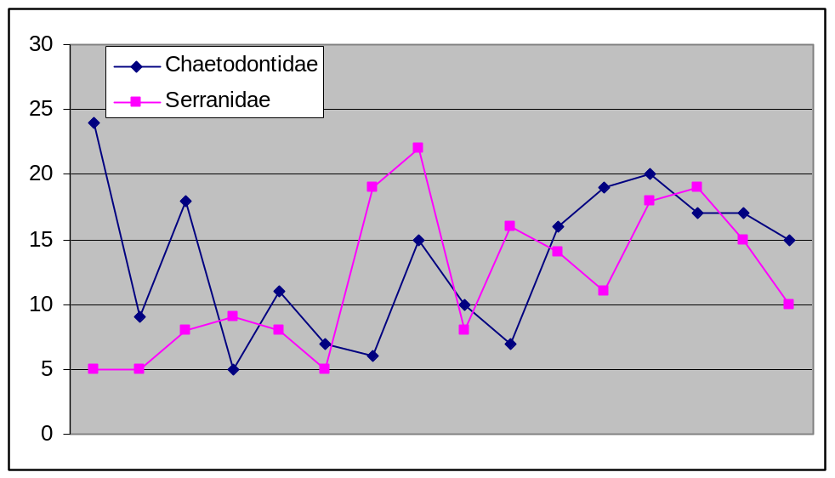
Figure 71: The number of both fish families observed on the 10m transect between July and November 2003

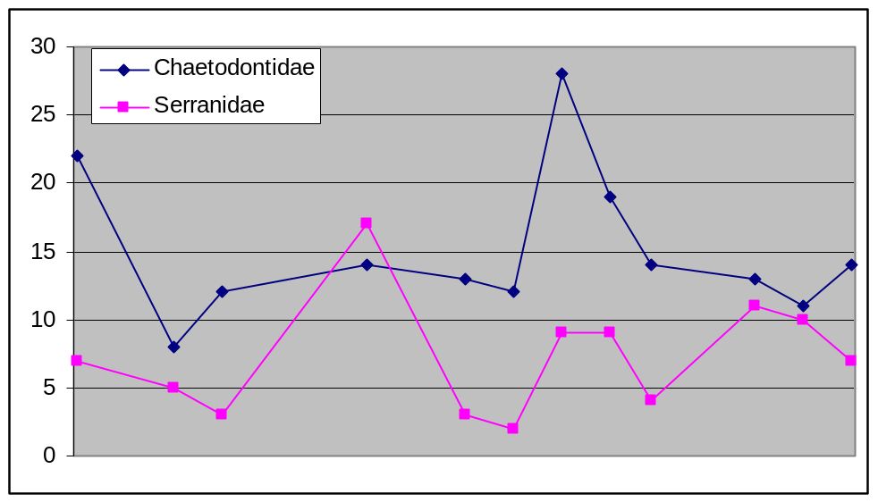
Figure 72: The number of both fish families observed on the 20m transect between July and November 2003

6.2 Exploratory diving
The fringing reef slope of Aldabra has been systematically explored during the course of the year. Figure 73 shows the sections covered thus far and makes mention of the recreational potential of each section. Table 35 describes the topography, coral and fish diversity and the bottom structure in more detail. An MS Excel database was created in order to record each dive site in even greater detail. The database makes provision for the GPS co-ordinates of the start and end of each dive, the dive route (in depth and time) along the reef slope, the most common fish species, other interesting observations and a crude map of the reef slope (see appendix 7). With this data, it would be possible to re-trace a particular dive in order to relocate an area of interest.
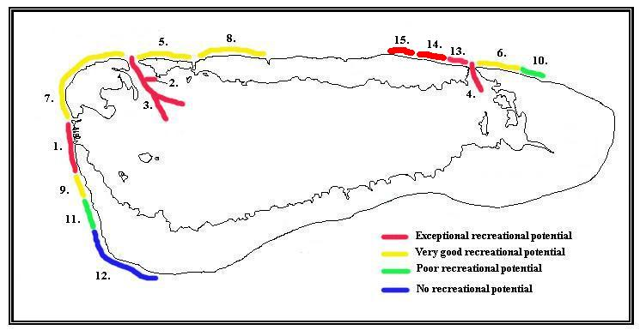
Figure 73: Exploratory dive sites indicating levels of recreational potential

Table 35: A detailed list of exploratory dives conducted in 2003
Section | % Bottom structure | Coral diversity (1-5) | Fish spp. diversity (1-5) | Topography | Reef slope | Comments
1 | 80% | 5 | 5 | Bommies, overhangs and crevices | Gentle | Astounding diversity and abundance of fishes and corals. Excellent for recreation and research
2 | N/A | 5 | 3 | Sheer walls on either side of narrow channel | N/A | Passé Nicois (tributary of main channel) Sheer walls of extensive coral colonies. Gentle current, shallow (10-15m).
3 | 50% | 2 | 1 | Steep walls, canyons, flat sections. | N/A | Main Channel, thrilling dive due to fast current. Spectacular scenery but not species rich.
4 | N/A | 5 | 4 | Sheer walls on either side of narrow channel | N/A | Much like Passé Nicois except faster current and better fish diversity.
5 | 70% | 4 | 3 | Rubble, sandy patches, bommies, overhangs, crevices | Gentle | Good place for viewing pelagic fish and sharks. Lots of large fish, turtles and rays.
6 | 60% | 3 | 4 | Rubble, bommies, young coral growth, 50º drop-off to 50m+ | Steep | Good place for deep dives. Shallow sections (10m) has good coral colonies, deeper coral is patchy.
7 | 80% | 4 | 4 | Coral colonies, bommies, sandy patches with rubble | Variable, from steep to gentle | Some rubbish seen on reef (bottles, drums, piping etc.) Diverse topography and reef slope angles makes for interesting diving.
8 | 60% | 3 | 4 | "Hilly", sand bars with rubble, extensive coral colonies. | Stepped and gentle | Interesting scenery. Gently sloping "hills" interspersed by sandbars with numerous large ray species. Occasional steep drop-offs.
9 | 80% | 3 | 4 | Massive bommies, overhangs, sandbars. | Gentle | Extensive coral communities (Including plate corals). Huge overhangs teeming with life, lots of Carangids.
10 | 50% | 2 | 3 | Mostly sand covered in rubble with some bommies | Gentle | Lots of pelagic fish around sparse bottom structure. Coral communities are limited by reduced bottom structure.
11 | 60% | 3 | 3 | Sand bars, shallow, intermittent, zigzagging reef. | Very gentle | Large expanses of sand broken by zigzagging reef at shallow depth. Where coral is extensive, large aggregations of fish.
12 | 40% | 2 | 2 | Sandy, limited structure all shallow. | Very gentle | Zigzagging reef at very shallow depths (5-10m). Poor fish and coral diversity
13 | 60% | 2 | 3 | Lots of rubble. Young coral growth becoming more established Westward. | Very steep | Lots of pelagic fish and massive shoals of plankton-eating fish in mid-water. Spectacular drop-off on a 50º slope going to great depths. Coral more pronounced at shallow depths.
14 | 60% | 3 | 4 | Gently sloping reef with massive bommies | Gentle | The massive bommies have caves that can be entered. Large groupers and pelagic fish about
15 | 60% | 3 | 4 | Massive bommies with gullies and some hills | Variable, from steep to gentle | Amazing changes in topography. Dense corral colonies in shallower water, numerous grey reef sharks seen.
6.3 Whale sightings
Humpback whales (Megaptera novaeangliae) were sighted off Aldabra between July and September this year. Usually the whales remain in the area until early the following year, this year however; none have been sighted since the tenth of September. Ten short finned pilot whales (G. Macrorhynchus) were sighted outside the main channel in July. In addition, 2 sperm whales (Physeter macrocephalus) were sighted between Assumption and Aldabra in February this year.

Table 36: Whales sightings for 2003
Date | Place | Species | Abundance | Notes | Observers
27/2/2003 | DDM-DJL | Sperm whales | 2 adults | 10km offshore | Joe, Andre, Uzice
9/7/2003 | Station | Humpback Whales | Undetermined | Moving south along coast, seen from shore | all
13/7/2003 | Station | Humpback Whales | Undetermined | Moving along shore north of station | GE
14/7/2003 | 1km north of main channel | Pilot whales-short finned (G. macrorhynchus) | 10 | Moving slowly north about 700m offshore. Unperturbed by bumboat | KG,RvB,TM,SS,JP,SB
29/7/2003 | Picard -Off Settlement reef | Humpback Whales | 2 | Moving slowly north | GE, RvB
11/8/2003 | Picard -Off Settlement reef | Humpback Whales | Undetermined (est-2) | Relatively stationary or moving slowly | GE
12/8/2003 | Picard -Off Settlement reef | Humpback Whales | Undetermined (est-2) | Relatively stationary or moving slowly | RvB,GE
14/8/2003 | Picard -Off Settlement reef | Humpback Whales | Undetermined (est-2) | Relatively stationary or moving slowly | RvB,GE
15/8/2003 | Picard -Off Settlement reef | Humpback Whales | Undetermined (est-2) | Relatively stationary or moving slowly | GE
16/8/2003 | Picard -Off Settlement reef | Humpback Whales | Undetermined (est-2) | Relatively stationary or moving slowly | JP, SS
17/8/2003 | Picard -Off Settlement reef | Humpback Whales | Undetermined (est-3) | Relatively stationary or moving slowly | Station staff -all
18/8/2003 | Main channel area | Humpback Whales | 2 (adult, sub adult) | Moving S toward station. | All rangers, RVB
19/8/2003 | Picard -Off Settlement reef | Humpback Whales | Undetermined (est-2) | Relatively stationary or moving slowly | Station staff -all
20/8/2003 | Picard -Off Settlement reef | Humpback Whales | Undetermined (est-2) | Relatively stationary or moving slowly | Station staff -all
21/8/2003 | Picard -Off Settlement reef | Humpback Whales | Undetermined (est-2) | Relatively stationary or moving slowly | Station staff -all
22/8/2003 | Picard -Off Settlement reef | Humpback Whales | Undetermined (est-2) | Relatively stationary or moving slowly | Station staff -all
9/9/2003 | Pass Houareau | Humpback Whales | Undetermined (est-2) | Moving along slowly | Research team
10/9/2003 | Pass Houareau | Humpback Whales | Undetermined (est-2) | Moving along slowly | Research team

6.4 The Dugong (Dugong dugong)
Several sightings of the Dugong were made during 2003 (table 37). It has been confirmed that at least 2 dugongs are resident at Aldabra with one individual being much larger than the other. Now that we have a trained pilot (Terence Mahoune), the FIB will be used to determine the number and habitat preference of these strange and illusive creatures. In addition, there exists a strong suspicion that the dugongs utilize the deep, slow flowing waters just north east of Ile Esprit as a resting ground during the low tide. This area will be searched systematically with the use of scuba diving equipment next year.

Table 37: Dugong sightings since 2001
Location | date | time | Recorders | Abundance | Notes
Bras Monsieur Claremont | 2/8/2001 | ? | Anna Liljevik | 1
Bras Monsieur Claremont | 3/8/2001 | ? | Anna Liljevik | 1
Bras Monsieur Claremont | 1/10/2001 | ? | Anna Liljevik | 2
Bras Monsieur Claremont | 12/10/2001 | ? | Anna Liljevik | 1
Bras Monsieur Claremont | 11/11/2001 | ? | Anna Liljevik | 1
Bras Monsieur Claremont | 19/5/2003 | ? | Doi, Guy Esparon | 1 | Adult
Northern shores of Ile Esprit | 24/10/2003 | 17:30 | RvB, TM, US, SB | 1 | Juvenile
Northern shores of Ile Esprit | 25/10/2003 | 17:00 | Guy Esparon | 1 | Juvenile
Bras Monsieur Claremont | 25/10/2003 | 17:30 | Guy Esparon | 1 | Adult
Bras Monsieur Claremont | 14/12/2003 | 8:00 | Doi, TM | 1 | Juvenile
Northern shores of Ile Esprit | 16/12/2003 | 8:00 | Doi, TM, M. Lalanne | 1 | Adult

